**Mini Project On**

**Modern Web Development Workshop - I**

# (CSE 2191)

**Submitted by**

**Name :**

**Reg. No. :**

**Branch :**

**Semester :**

**Section :**

**Session : 2023-2024**

**Admission Batch : 2022**



**DEPARTMENT OF COMPUTER SCIENCE & INFORMATION TECHNOLOGY FACULTY OF ENGINEERING & TECHNOLOGY (ITER)**

**SIKSHA ‘O’ ANUSANDHAN DEEMED TO BE UNIVERSITY BHUBANESWAR, ODISHA – 751030**

**1.COURSE INFORMATION PAGE:-**

**CODE-**

<!DOCTYPE html>

<html>

<head>

<title>Course Information</title>

<style>

h2 {

color:MediumSeaGreen;

}

</style>

</head>

<body>

<body style="background-color:black;"> <font color="white">

<!--Centered Image Start-->

<div style="text-align: center;">

<img src="fdi.jpeg"> </div>

<div>

<h2><i><b>Course 1 : Master in Frontend Development </i></b></h2>

<ud>

<li><b>Course code : </b>PROG100</li>

<li><b>Cost : </b>Rs.1300</li>

<li><b>Duration : </b>8 weeks</li>

<li><b>What you'll learn : </b><br>Create a responsive website using HTML to structure content, CSS to handle visual style, and JavaScript to develop interactive experiences.<br> Prepare for a coding interview, learn best approaches to problem-solving, and build portfolio-ready projects you can share during job interviews.<br></li>

</ud>

</div>

<div>

<h2><i><b>Course 2 : Datastructure & Algorithm in C++ </i></b></h2>

<ud>

<li><b>Course code : </b>DSA101</li>

<li><b>Cost : </b>Rs.1500</li>

<li><b>Duration : </b>12 weeks</li>

<li><b>What you'll learn : </b><br>Apply algorithmic techniques (greedy algorithms, binary search, dynamic programming, etc.) and data structures (stacks, queues, trees, graphs, etc.) to solve 100 programming challenges that often appear at interviews at high-tech companies.<br>

Learn best approaches to problem-solving.<br></li>

</ud>

</div>

<div>

<h2><i><b>Course 3 : Data Science Foundation </i></b></h2>

<ud>

<li><b>Course code : </b>DATA201</li>

<li><b>Cost : </b>Rs.1400</li>

<li><b>Duration : </b>10 weeks</li>

<li><b>What you'll learn : </b><br> Understand common careers and industries that use advanced data analytics.<br>Investigate the impact data analysis can have on decision

making.<br>Develop a project plan considering roles and responsibilities of team members.<br></li>

</ud>

</div>

<div>

<h2><i><b>Course 4 : DevOps Engineering - Planning to Production </i></b></h2>

<ud>

<li><b>Course code : </b>DES101</li>

<li><b>Cost : </b>Rs.2350</li>

<li><b>Duration : </b>18 weeks</li>

<li><b>What you'll learn : </b><br> Create applications using Python language, using various programming constructs and logic, including functions, REST APIs, and libraries.<br> Develop a DevOps mindset, practice Agile philosophy & Scrum methodology - essential to succeed in the era of Cloud Native Software Engineering.<br> Build applications composed of microservices and deploy using containers (e.g. Docker, Kubernetes, and OpenShift) & serverless technologies.<br></li>

</ud>

</div>

<div>

<h2><i><b>Course 5 : UX/UI Design </i></b></h2>

<ud>

<li><b>Course code : </b>UX001</li>

<li><b>Cost : </b>Rs.1200</li>

<li><b>Duration : </b>9 weeks</li>

<li><b>What you'll learn : </b><br>Understand the basics of UX research, like planning research studies, conducting interviews and usability studies, and synthesizing research results.<br>Follow the design process: empathize with users, define pain points, ideate solutions, create wireframes and prototypes, test and iterate on designs.<br>Create a professional UX portfolio that includes 3 end-to-end projects: a mobile app, a responsive website, and a cross-platform experience.<br></li>

</ud>

</div>

</body>

</html>

**OUTPUT**

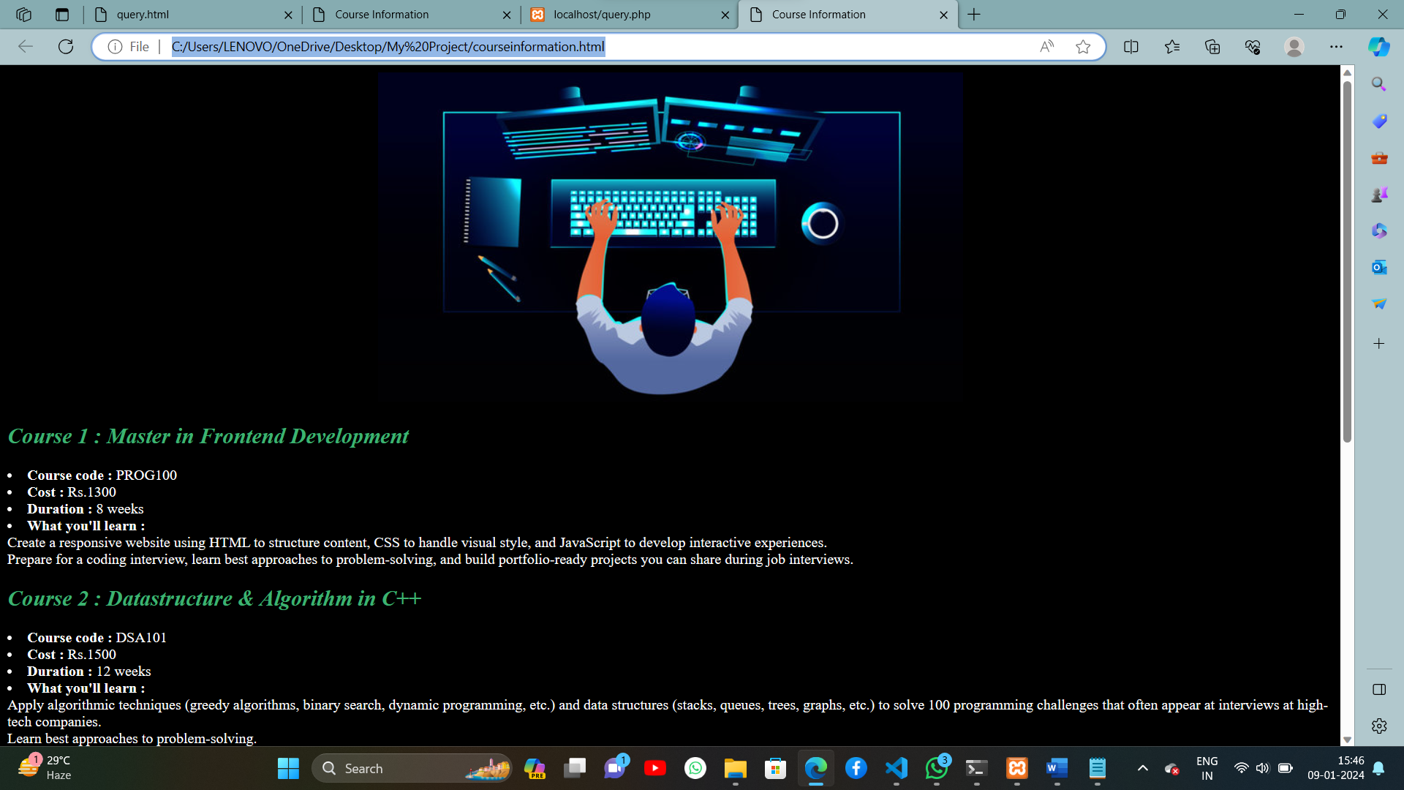



**2.USER REGISTRATION:-**

**SQL DATABASE:-**

1.CREATE TABLE users (

id INT AUTO_INCREMENT PRIMARY KEY,

name VARCHAR(255),

email VARCHAR(255) UNIQUE,

password VARCHAR(255),

subject_code VARCHAR(10)

);

2.CREATE TABLE queries (

id INT AUTO_INCREMENT PRIMARY KEY,

name VARCHAR(255),

Query VARCHAR(255) UNIQUE,

);

**REGISTRATION (HTML CODE):-**

<!DOCTYPE html>

<html lang="en">

    <head>

        <meta charset="UTF-8">

        <meta name="viewport" content="width=device-width, initial-scale=1.0">

        <title>User Registration</title>

        <style>

            body {

                font-family: Arial, sans-serif;

                background-color: #f4f4f4;

                margin: 0;

                padding: 0;

                display: flex;

                justify-content: center;

                align-items: center;

                height: 100vh;

}

            form {

                background-color: #fff;

                padding: 20px;

                border-radius: 8px;

                box-shadow: 0 0 10px rgba(0, 0, 0, 0.1);

                max-width: 400px;

                width: 100%;

            }

            label {

                display: block;

                margin-bottom: 8px;

            }

            input {

                width: 100%;

                padding: 8px;

                margin-bottom: 16px;

                box-sizing: border-box;

                border: 1px solid #ccc;

                border-radius: 4px;

            }

            input[type="submit"] {

                background-color: #4caf50;

                color: #fff;

                cursor: pointer;

            }

            input[type="submit"]:hover {

                background-color: #45a049;

            }

        </style>

    </head>

<body background = "backgroundimg3.jpg">

    <form action="http://localhost:3000/register.php" method="post">

        <label for="name">Name : </label>

        <input placeholder="Username" type="text" name="name" required>

        <br>

        <label for="email">Email : </label>

        <input placeholder="eg:ashutosh01@gmail.com" type="email" name="email" required>

        <br>

        <label for="password">Password : </label>

        <input placeholder="abc@123" type="password" name="password" required>

        <br>

        <label for="subjectcode">Subject Code : </label>

        <select name="subjectcode" required>

            <option>PROG101</option>

            <option>DSA101</option>

            <option>DATA201</option>

            <option>DEV101</option>

            <option>UX001</option>

        </select>

        <br>

        <input type="submit" value="REGISTER">

    </form>

</body>

</html>

**REGISTRATION (PHP CODE):-**

<?php

$servername="localhost";

$username="root";

$password="";

$dbname="register";

$conn= new mysqli($servername,$username,$password,$dbname);

if ($conn->connect_error){

    die("Connection failed: ". $conn->connect_error);

}

if($_SERVER["REQUEST_METHOD"] == "POST"){

    $name=$_POST["name"];

    $email= $_POST["email"];

    $password= $_POST["password"];

    $subjectcode= $_POST["subjectcode"];

    if(strlen($password)<8){

        die("Password should be atleast 8 characters long.");

    }

    $hashedPassword = password_hash($password,PASSWORD_BCRYPT);

    $sql= "INSERT INTO user(name,email,password,subjectcode) VALUES('$name','$email','$password','$subjectcode')";

    if($conn->query($sql) == TRUE) {

        echo "Registration successful.";

    }

    else {

        echo "ERROR:." .$sql. "<br>". $conn->error;

    }

}

$conn->close();

?>

**OUTPUT**

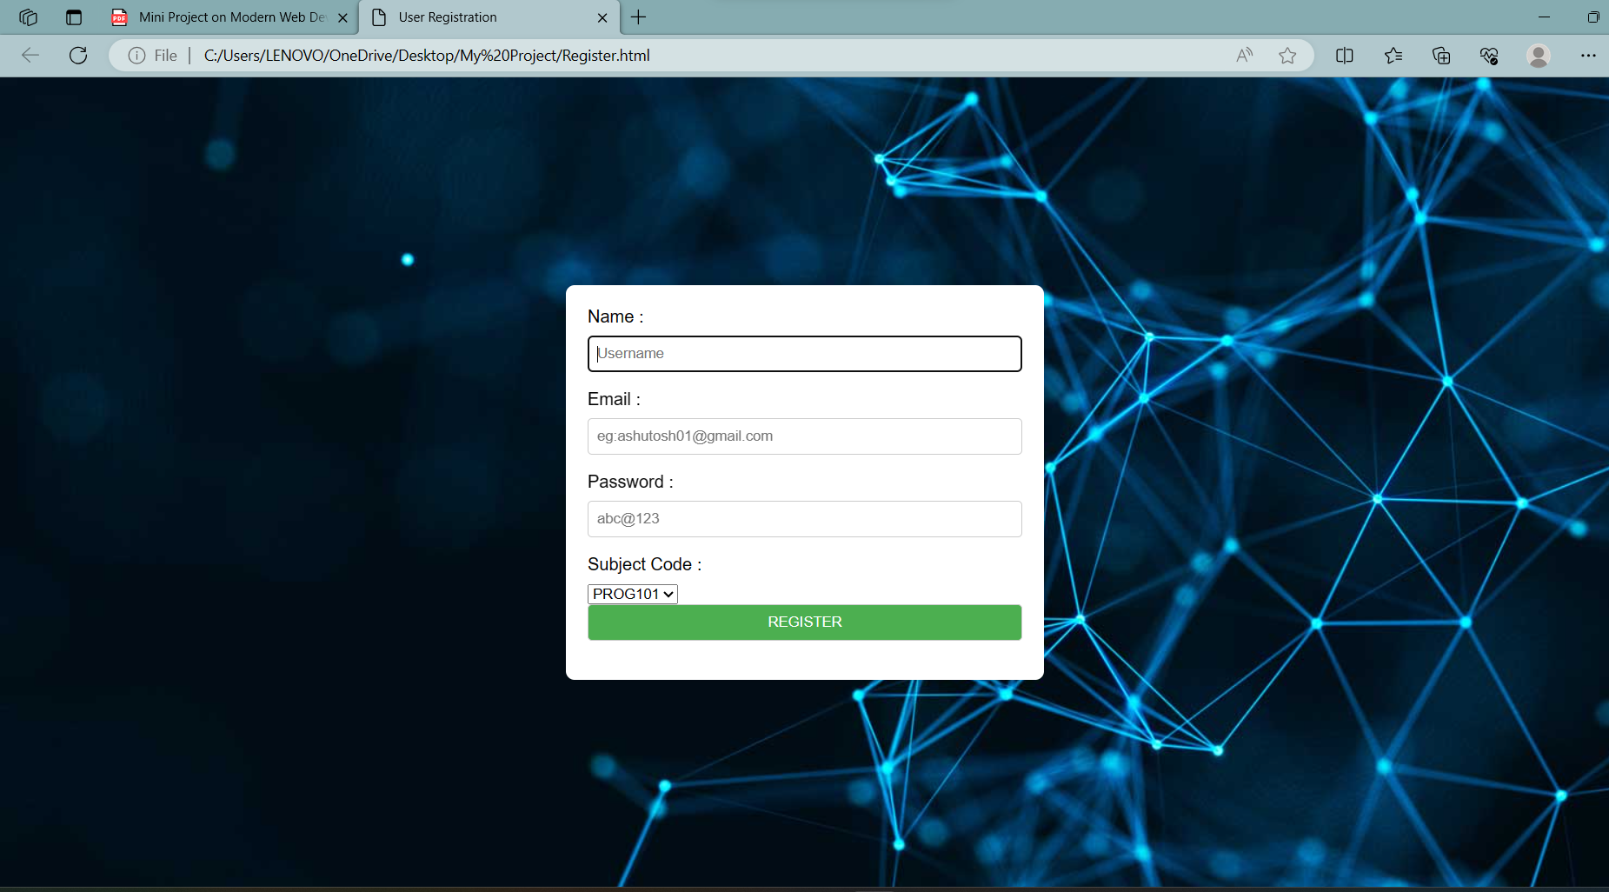

**SQL DATA FOR REGISTRATED USER**

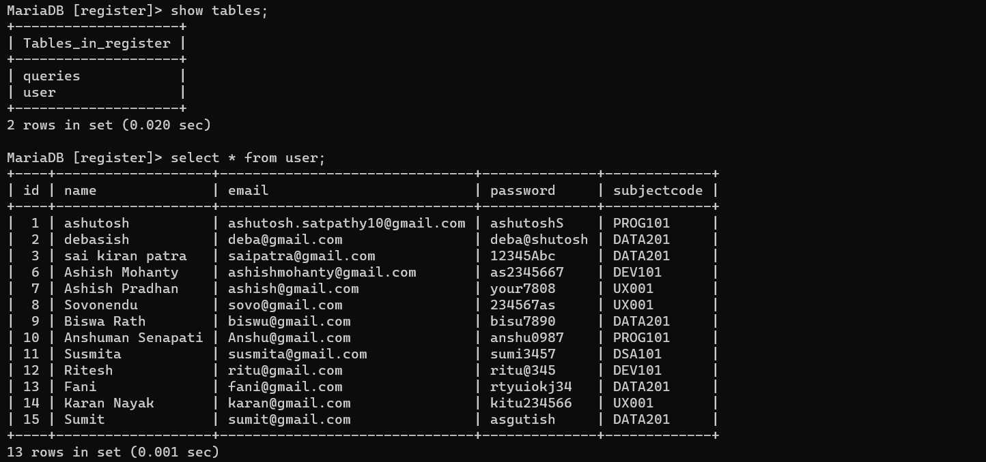

**3.QUERY FORM -**

**QUERY(HTML) –**

<html>

<style>

body {

font-family: Arial, sans-serif;

background-color: #f4f4f4;

margin: 0;

padding: 0;

display: flex;

justify-content: center;

align-items: center;

height: 100vh;

}form {

background-color: #fff;

padding: 20px;

border-radius: 8px;

box-shadow: 0 0 10px rgba(0, 0, 0, 0.1);

max-width: 400px;

width: 100%;

}

label {

display: block;

margin-bottom: 8px;

}

input, textarea {

width: 100%;

padding: 8px;

margin-bottom: 16px;

box-sizing: border-box;

border: 1px solid #ccc;

border-radius: 4px; }

textarea {

resize: vertical;

}

input[type="submit"] {

background-color: #4caf50;

color: #fff;

cursor: pointer;

}

input[type="submit"]:hover {

background-color: #45a049;

}

</style></head>

<body background="backgroundimg.jpg">

<form action ="http://localhost/query.php" method="post">

<b> FOR ANY OTHER INFORMATION OR ANY QUERIES </b>

<label for ="name">Name</label>

<input placeholder="Username" type="text" name="name" required><br>

<label for ="UserQuery">Your Query:</label>

<textarea id="query" name="query" required></textarea>

<button type="submit">Submit Query </button>

</form>

</body>

</html>

**QUERY(PHP) –**

<?php

$servername="localhost";

$username="root";

$password="";

$dbname="register";

$conn= new mysqli($servername,$username,$password,$dbname);

if ($conn->connect_error){

    die("Connection failed: ". $conn->connect_error);

}

    $query=$_POST["query"];

 $sql= "INSERT INTO queries(UserQuery) VALUES('$query')";

    if($conn->query($sql) == TRUE) {

        echo "Registration successful.";

    }

    else {

        echo "ERROR:." .$sql. "<br>". $conn->error;

    }

$conn->close();

?>

**OUTPUT**

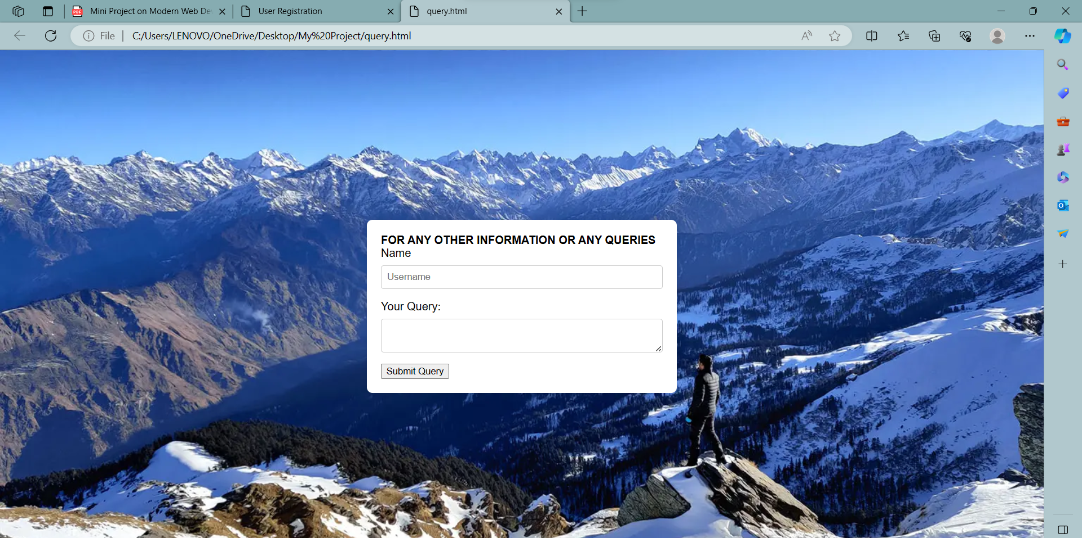

**SQL DATA FOR QUERIES OF USER**

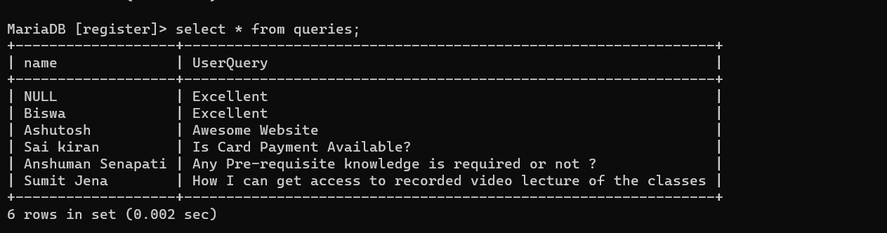

**4. DISPLAY REGISTERED USERS AND QUERY INFORMATION:-**

**DISPLAY REGISTRATION (PHP):-**

<!DOCTYPE html>

<html lang="en">

<head>

    <meta charset="UTF-8">

    <meta name="viewport" content="width=device-width, initial-scale=1.0">

    <title>Registered Individuals</title>

    <style>

        body {

            font-family: Arial, sans-serif;

            background-color: #f4f4f4;

            margin: 0;

            padding: 20px;

        }

        table {

            width: 100%;

            border-collapse: collapse;

            margin-top: 20px;

        }

        th, td {

            border: 1px solid #ddd;

            padding: 8px;

            text-align: left;

        }

        th {

            background-color: #4caf50;

            color: white;

        }

    </style>

</head>

<body>

    <h2>Registered Individuals</h2>

<?php

// Include the database connection file

$servername="localhost";

$username="root";

$password="";

$dbname="register";

$conn= new mysqli($servername,$username,$password,$dbname);

if ($conn->connect_error){

    die("Connection failed: ". $conn->connect_error);

}

// SQL query to retrieve registered users

$sql = "SELECT * FROM user";

$result = $conn->query($sql);

// HTML for displaying registered users

echo '<!DOCTYPE html>';

echo '<html lang="en">';

echo '<head>';

echo '<meta charset="UTF-8">';

echo '<meta name="viewport" content="width=device-width, initial-scale=1.0">';

echo '<title>Registered Users</title>';

echo '</head>';

echo '<body>';

echo '<table border="1">';

echo '<tr>';

echo '<th>ID</th>';

echo '<th>Name</th>';

echo '<th>Email</th>';

echo '<th>Course Code</th>';

echo '</tr>';

while ($row = $result->fetch_assoc()) {

    echo '<tr>';

    echo '<td>' . $row['id'] . '</td>';

    echo '<td>' . $row['name'] . '</td>';

    echo '<td>' . $row['email'] . '</td>';

    echo '<td>' . $row['subjectcode'] . '</td>';

    echo '</tr>';

}

echo '</table>';

echo '</body>';

echo '</html>';

// Close the database connection

$conn->close();

?>

**OUTPUT**

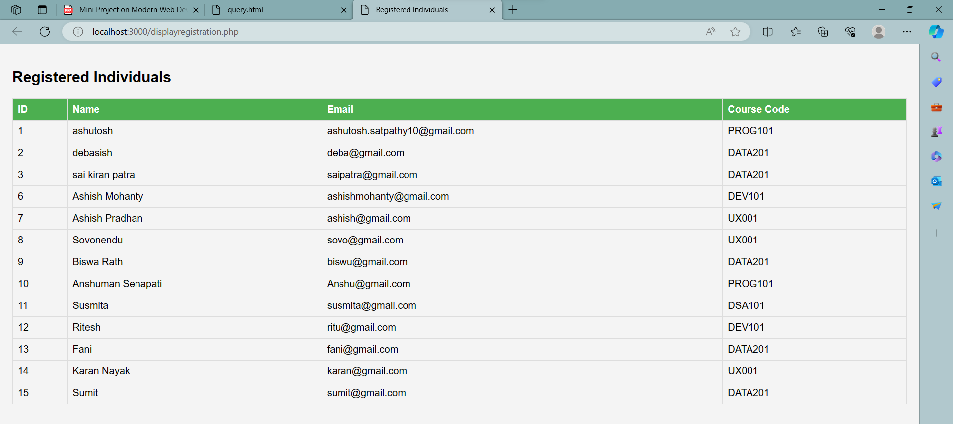

**DISPLAY QUERIES (PHP) -**

<!DOCTYPE html>

<html lang="en">

<head>

    <meta charset="UTF-8">

    <meta name="viewport" content="width=device-width, initial-scale=1.0">

    <title>Registered Individuals</title>

    <style>

        body {

            font-family: Arial, sans-serif;

            background-color: #f4f4f4;

            margin: 0;

            padding: 20px;

        }

        table {

            width: 100%;

            border-collapse: collapse;

            margin-top: 20px;

        }

        th, td {

            border: 1px solid #ddd;

            padding: 8px;

            text-align: left;

        }

        th {

            background-color: #4caf50;

            color: white;

        }

    </style>

</head>

<body>

<?php

// Include the database connection file

$servername="localhost";

$username="root";

$password="";

$dbname="register";

$conn= new mysqli($servername,$username,$password,$dbname);

if ($conn->connect_error){

    die("Connection failed: ". $conn->connect_error);

}

$sql = "SELECT * FROM queries";

$result = $conn->query($sql);

// HTML for displaying user queries

echo '<!DOCTYPE html>';

echo '<html lang="en">';

echo '<head>';

echo '<meta charset="UTF-8">';

echo '<meta name="viewport" content="width=device-width, initial-scale=1.0">';

echo '<title>User Queries</title>';

echo '</head>';

echo '<body>';

echo '<h2>User Queries</h2>';

echo '<table border="1">';

echo '<tr>';

echo '<th>Name</th>';

echo '<th>Query Text</th>';

echo '</tr>';

while ($row = $result->fetch_assoc()) {

    echo '<tr>';

    echo '<td>' . $row['name'] . '</td>';

    echo '<td>' . $row['UserQuery'] . '</td>';

    echo '</tr>';

}

echo '</table>';

echo '</body>';

echo '</html>';

// Close the database connection

$conn->close();

?>

**OUTPUT**

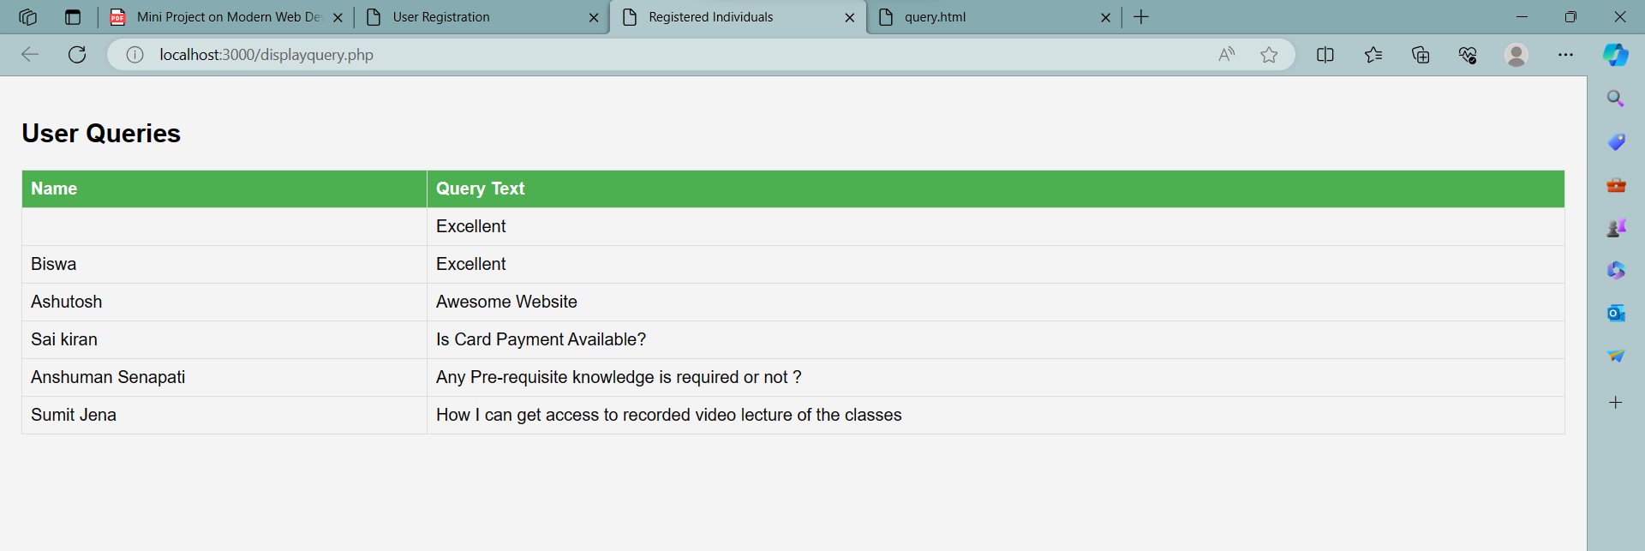

**DESIGNING WEBPAGE –**

**CODE**

<html lang="en">

<head>

<title>Online Course Website</title>

</head>

<body

background="bg5.jpg"

style="background-size: 100%;"

style="background-attachment: fixed;">

<br/>

<h3 align="center">

<font color="#ffffff"> ASHUTOSH'S__WEBPAGE</font>

&nbsp; &nbsp; &nbsp; &nbsp; &nbsp; &nbsp; &nbsp; &nbsp;

&nbsp; &nbsp; &nbsp; &nbsp; &nbsp; &nbsp; &nbsp; &nbsp;

&nbsp; &nbsp; &nbsp; &nbsp; &nbsp; &nbsp; &nbsp; &nbsp;

&nbsp; &nbsp; &nbsp; &nbsp; &nbsp; &nbsp; &nbsp; &nbsp;

&nbsp; &nbsp; &nbsp; &nbsp; &nbsp; &nbsp; &nbsp; &nbsp;

&nbsp; &nbsp; &nbsp; &nbsp; &nbsp; &nbsp; &nbsp; &nbsp;

&nbsp; &nbsp; &nbsp; &nbsp; &nbsp; &nbsp; &nbsp; &nbsp;

&nbsp; &nbsp; &nbsp; &nbsp; &nbsp; &nbsp; &nbsp; &nbsp;

&nbsp; &nbsp; &nbsp; &nbsp; &nbsp; &nbsp; &nbsp; &nbsp;

&nbsp; &nbsp; &nbsp; &nbsp; &nbsp; &nbsp; &nbsp; &nbsp;

<font face="Arial">

<style>

.glow {

font-size: 70px;

color: #ffffff;

text-align: center;

-webkit-animation: glow 1s ease-in-out infinite alternate;

-moz-animation: glow 1s ease-in-out infinite alternate;

animation: glow 1s ease-in-out infinite alternate;

}

@-webkit-keyframes glow {

from {

text-shadow: 0 0 10px #eeeeee, 0 0 20px #000000, 0 0 30px #000000, 0 0 40px #000000,

0 0 50px #9554b3, 0 0 60px #9554b3, 0 0 70px #9554b3;

}

to {

text-shadow: 0 0 20px #eeeeee, 0 0 30px #ff4da6, 0 0 40px #ff4da6, 0 0 50px #ff4da6,

0 0 60px #ff4da6, 0 0 70px #ff4da6, 0 0 80px #ff4da6;

}

}

</style> </head>

<body>

<h1 class="glow">WELCOME TO EDUZTECH </h1>

<a href="file:///C:/Users/LENOVO/OneDrive/Desktop/My%20Project/courseinformation.html"><font color="#ffffff">View Courses</font></a>&nbsp;&nbsp;&nbsp;

<a href="file:///C:/Users/LENOVO/OneDrive/Desktop/My%20Project/Register.html"><font color="#ffffff">Register</font></a>&nbsp;&nbsp;&nbsp;

<a href="file:///C:/Users/LENOVO/OneDrive/Desktop/My%20Project/query.html"><font color="#ffffff">Queries</font></a>&nbsp;&nbsp;&nbsp;

<a href="http://localhost:3000/displayregistration.php"><font color="#ffffff">Registered Users</font></a>&nbsp;&nbsp;&nbsp;

<a href="http://localhost:3000/displayquery.php"><font color="#ffffff">User Queries</font></a>

</font>

</h3>

<br><br><br><br><br><br>

<h3 align="center">

<font face ="Monospace" size="7" color="White" ><b>LEARN FROM GREAT EXPERIENCE </b></font>

</h3>

<h3 align="center">

<font face ="Monospace" size="4" color="white" ><b>CLICK BELOW TO REGISTER</b></font>

</h3>

<h3 align="center">

<p><a href="file:///C:/Users/LENOVO/OneDrive/Desktop/My%20Project/Register.html">

<img src="register2.jpg" width="200">

</a></p>

</h3>

</body>

</html>

**OUTPUT**

